Rossmore Primary School
Feedback and Marking Policy
At Rossmore, we recognise the importance of feedback as an integral part of the teaching and learning cycle, and aim to maximise the effectiveness of its use in practice. We are mindful also of the research surrounding effective feedback and the workload implications of written marking.
Our policy is underpinned by the evidence of best practice from the Education Endowment Foundation and other expert organisations. Education Endowment Foundation research shows that effective feedback should:
- Redirect or refocus either the teacher’s or the learner’s actions to achieve a goal
- Be specific, accurate and clear
- Encourage and support further effort
- Be given sparingly so that it is meaningful
- Put the onus on students to correct their own mistakes, rather than providing correct answers for them
- Alert the teacher to misconceptions, so that the teacher can address these in subsequent lessons.

Key Principles
Our policy on feedback has at its core a number of principles:
- The sole focus of feedback should be to further children’s learning;
- Evidence of feedback is incidental to the process; we do not provide additional evidence for external verification;
- Feedback should empower children to take responsibility for improving their own work; it should not take away from this responsibility by adults doing the hard thinking work for the pupil.
- Written comments should only be used as a last resort for the very few children who otherwise are unable to locate their own errors, even after guided modelling by the teacher.
- Children should receive feedback regularly and consistently throughout the lesson itself.
- Feedback should show that we value the children’s work and encourage them to value it too, boosting self-esteem and raising aspirations through the use of praise and encouragement.

Feedback = Responsive Teaching
It is vital that teachers evaluate the work that children undertake in lessons, and use information obtained from this to allow them to adjust their teaching. There are six ways that a teacher can adjust their teaching to respond to the needs of the children.
1. Reteach
2. Revise
3. Redraft
4. Practice
5. Check
6. Move on

Feedback and Marking in practice

Type | What it looks like | Evidence (for observers)
Immediate  (within the lesson) | - Includes teacher gathering feedback from teaching within the course of the lesson, including mini-whiteboards, bookwork, etc.  - Takes place in lessons with individuals or small groups  - Often given verbally to pupils for immediate action  - May involve use of a teaching assistant to provide support of further challenge  - May re-direct the focus of teaching or the task  - Other AFL strategies (ABCD cards, hinge questions etc)  - Use of visualiser | • Lesson observations/learning walks  Teachers will record any immediate feedback with the symbol VF if it has meant the child has had to go back and improve/’purple polish’.
Summary  (at the end of the lesson) | - Takes place at the end of a lesson of activity  - Often involves whole groups or classes  - Provides an opportunity for evaluation of learning in the lesson  - May take form of self or peer- assessment against an agreed set of criteria  - May take the form of a quiz, test or score on a game  - In some cases, may guide a teacher’s further use of review feedback, focusing on areas of need  - Teacher and support staff to huddle and group books into piles to inform next steps.  - Exit passes  - Stem sentences using but, because, so  - Balance Assessment Tool 0-9 | - Lesson observations/learning walks  - Some evidence of self – and peer-assessment  - Quiz and test results may be recorded in books or logged separately by the teacher  - Balance data
Feedforward:  (next step/lesson) | - For writing in particular, often a large part of the next lesson will be spent giving feedback to the class about strengths and areas for development, and giving time for development areas to be worked on and improved through proof reading and editing their work.  - Do now’s are analysed daily and errors and misconceptions addressed in subsequent lessons, in particular in maths meetings.  - Visualiser | •  • | Lesson  observations/learning walks  Evidence in books of pupils editing and redrafting their work.
Summative | - ‘Check it’ activities  - End of unit or term tests or quizzes | • | Check it activities in books
 |  | • | Quiz and test results
Date of policy: September 2022
Review date: September 2024

Appendix
Guidance for teachers

Proof reading and editing in writing lessons
Writing lessons will be followed up with an editing lesson as and when needed. Children will receive whole class feedback about strengths and areas for development and direct teaching about how to help them identify and address their own weaknesses.
The editing lesson can be divided into two sections
- proofreading
Changing punctuation, spelling, handwriting and grammar mistakes.
- editing
Improving their work to improve the composition.
Teachers will have looked at pupils’ work soon after the previous lesson and identified strengths and weaknesses, looking at both the technical accuracy of the writing; spelling errors, punctuation omissions, and other transcription mishaps as well as things to do with the sophistication of the writing; the actual content. Where individual children have done particularly well or badly at something, s/he will make a note and use these in the lesson as a teaching point.
The teacher will share extracts from pupils’ work, using either the visualiser or by typing out a couple of lines and displaying them on the interactive whiteboard, at first showing good examples of work. For example, within the proof reading section, the teacher might showcase someone whose letter heights have the ascenders and descenders just right, then asking pupils to look at their work and rewrite one sentence from it, really making sure they are paying attention to letter heights. Then s/he might share a section of text with poor punctuation (usually anonymously) and reteach the class the various punctuation rules. They might then point out some spelling errors that several children are making, and remind children of the correct spelling and how to remember it. Children will then have a short period of time to proof read their work, checking for similar errors and putting them right. Children could sit with their learning partners and support each other in the identification and correction of mistakes.
For example, the teacher might show a different couple of pieces of work where children have described a character very well, pointing out what it is that has made the description so vivid. The teacher might then share a weaker example which might be from an anonymous or fictional piece. The children would then suggest together how this might be improved. Then in their pairs they read together each other’s work, and suggest improvements, alterations and refinements which the author of the piece then adds – in purple pen to help the teacher see what changes the child has made.

Intervening when children find editing hard
A few children will need more support than this in order to be successful at improving their own work. Younger children in KS1 in particular may need more support as they learn to become more independent, although many young children are quite able to edit and proof read independently after teacher modelling.
As with all interventions, teachers should always seek to use the minimal level possible, only escalating to the next level if the child still needs further support. Some children may need a gentle prompt to narrow down their focus when looking for mistakes, for example a written comment alerting them that there are some missing full stops, without telling them how many or where. Or a simple pointer – ‘description’ perhaps or ‘ambiguous pronouns’ or ‘figurative language’. This would be in addition to, and not instead of, the teacher modelling editing for these before the independent section of the lesson. Others might need even more support and need to be provided with clues to help them. For example, the teacher might need to draw a green box around a section of text to narrow down the search area for the pupil, alongside the comment that there are speech marks missing or tenses jumped or the same sentence structure over-used.
Where mistakes are deeply entrenched, or the children are very young and lack confidence, the teacher may intervene and do some direct work, modelling how to overcome these: for example, to clear up the confusion with apostrophe use. The teacher might set a group of children an editing challenge based not on their own work but on a fictional piece of work with only one, recurrent error. An adult might then support the group in identifying where apostrophes do and do not belong. They might do this instead of editing their own work or as a prelude to it, depending upon their learning needs. But what the teacher is not doing is using a marking code that does all the error identification for the pupil as this takes away any responsibility from the pupil at thinking hard about how to improve.

The strategical minimal marking triangle (The MITA Triangle)
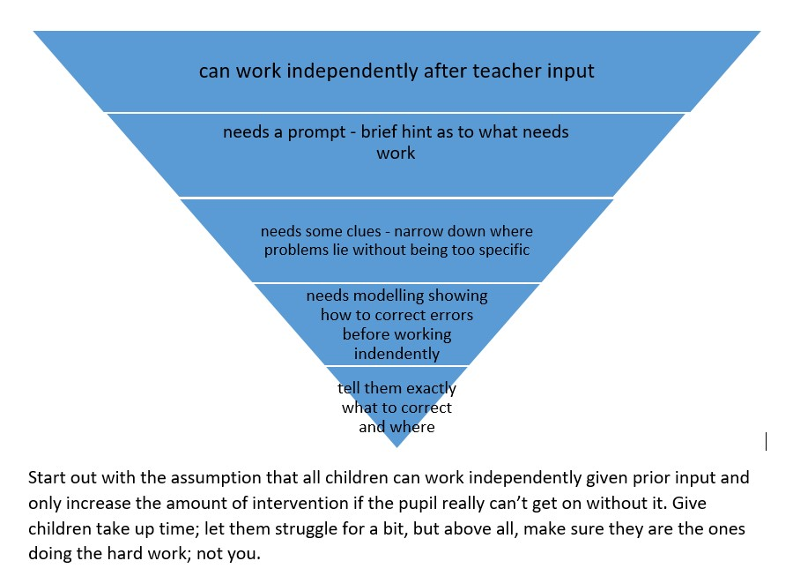
Sometimes it is children who find writing easy who do not challenge themselves to improve their writing through editing, settling too readily for their first attempt. These children may initially need specific clues about what an even better piece of writing might look like.
◆ Set group or individual challenges, “before you’ve finished editing, you need to have…  Use their work in modelling and then expect them to do the same.

Feedback in maths
Teachers gain valuable feedback about how much maths teaching is being retained in the longer term from the daily ‘do now’ sessions at the start of lessons in ks1 and lower ks2. This information should be used to revisit areas where learning is not secure within maths meetings. ‘Check its’ given at least 3 weeks after teaching a unit and end of unit tests also provide vital feedback to the teacher about areas that might need more teaching for certain individuals either in class or through an intervention.
In terms of day to day maths learning, in ks2, teachers should have the answers to problems available, and after doing 4 or 5 calculations, children should check their answers themselves. That way, if they have got the wrong end of the stick and misunderstood something, they can alert the teacher immediately. Another benefit is that less confident children might want to start at the easiest level of work provided, but with instant feedback available, after getting their first few calculations correct, they feel confident to move to the next level. Another strategy teachers can use is to get children to compare answers in a group and where answers do not agree, challenge each other and try and find where the other person has gone wrong.
Where children are more confident, and finish their work slightly earlier than others, they can consolidate their learning by ‘marking’ other children’s books. When they do this, the crucial step is that they should not take their own book with them and just read off the correct answer. They should do the calculations again – faster and possibly mentally – so in effect doing the work twice thus getting the sort of over-learning that leads to solid long-term retention.
The onus is always on the learner checking their work and if they’ve got an answer wrong, trying to identify their own errors. Children need to be taught how to do this purposely; otherwise they think it just means scanning quickly through their work, reading but not really thinking. Checking involves thinking deeply about the work you have just learnt. When you think deeply about something, it is much more likely to get stored in your long term memory, available to be recalled at will. As Daniel Willingham says ‘memory is the residue of thought.’ So as an alternative to providing the answers, teachers should sometimes use the visualiser to model ways of checking and then expect children to do the same, in effect ‘proof reading’ maths. So for example, children might repeat a calculation in a different coloured pen and check they’ve got the same answer. For addition calculations involving more than two numbers, adding the numbers in a different order is an even better way of checking. Teachers should model how children can use the inverse operation to go and check they get back to where they started.
With 2 or 3 part word problems, a classic error is to give the answer as the first part of the problem and forget about following through to the second (or third) part of the question. Often, word problems are written with each instruction on a different line, a bit like success criteria. Again, using a visualiser, teachers should show children how to check work as we go, returning to the question and ticking off each line – writing each answer alongside, being really clear we are answering the final question, having done all of the previous steps.
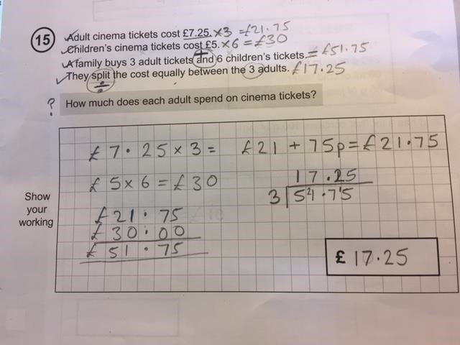

Giving children work to mark from fictitious other children, which includes all the common misconceptions, is a really good way of helping them develop this.

Feedback in other subjects
Teachers will follow the same practice in other subject areas as they do in Literacy in Maths – giving timely and effective feedback that helps move the children’s learning on. Feedback will be given as whole class or to small groups (or to individual children if this is deemed necessary for specific intervention) and children will be given the appropriate time to make any corrections or additions to their work following this. This can be done during a lesson (where mistakes or misconceptions have been spotted immediately) or at the beginning of the next lesson before new learning is introduced.
Where there are many children in the class with similar misconceptions, a new lesson may be planned for the whole class to ensure that this does not continue further into the unit.

