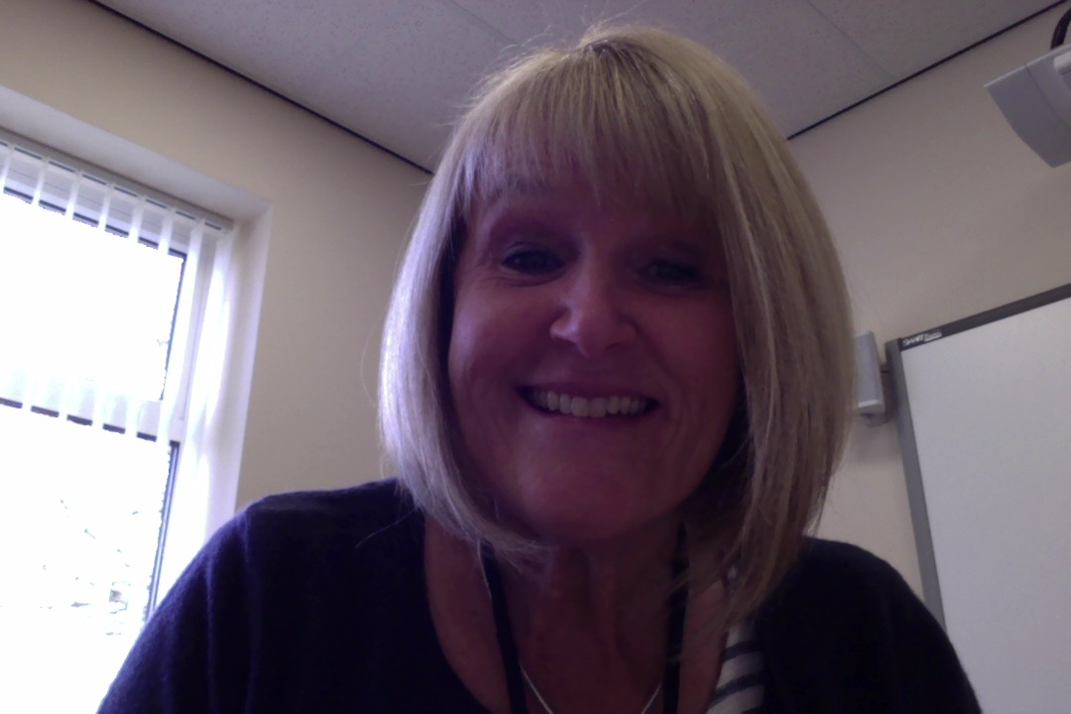
Hi, just wanted to send you a smile and to say well done for working hard whilst you are at home.
Sending You A Smile
The work I am seeing is making me very proud of you all.
Well done.

KEEP SAFE!

Missing You All So Much
Take care

Mrs Davis-McCoy

